
Department of Computer Science and Engineering
Islamic University of Technology (IUT)
A subsidiary organ of OIC

Lab Report 02

CSE 4512 : Computer Networks Lab

Name:Md. Abdullah Al Jubaer Gem
Student ID:210041226
Section:2B
Semester:5th
Academic Year:2023-2024

Date of Submission:22-09-2024

Title: Configure router using static routing to connect multiple networks in Cisco Packet Tracer

Objectives:
- Understand how to operate Cisco Packet Tracer
- Learn to create and connect multiple networks using static routing
- Understand wiring of different network components like router, switch, PC etc.
- Configure router and switch interfaces
- Verify connectivity of the network

Diagram of the experiment:

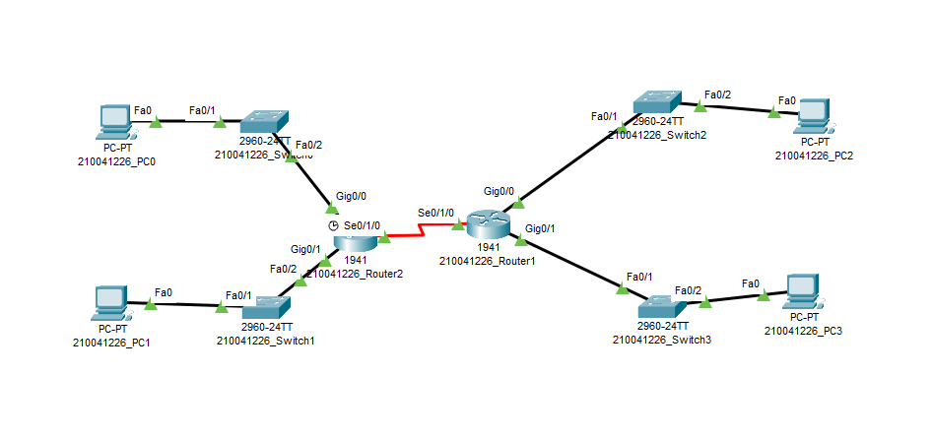

Working Procedure:
(Explain in brief how you completed the tasks. Provide necessary screenshots of used commands for each task.)
- Firstly all the devices like routers, switches and PCs were set up and labeled.
- Then incase of both routers a HWIC-2T interface with 2 serial ports was added.
  - 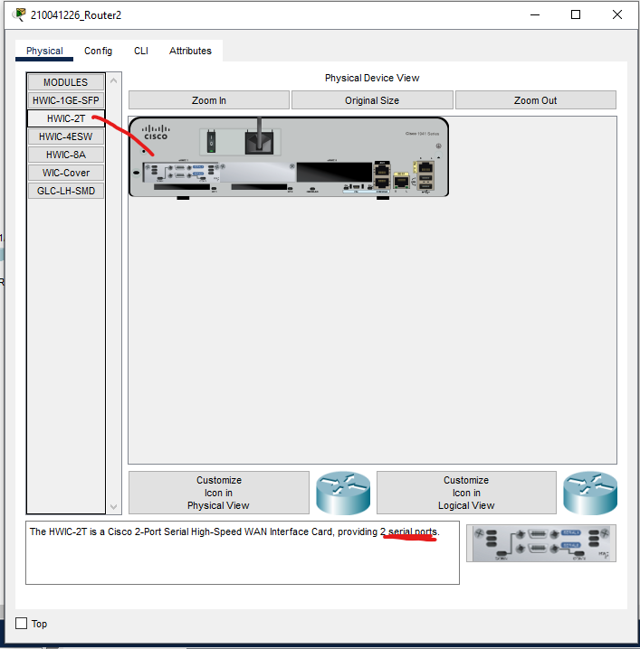

- Then all the connections were made via this
- After that all the IP addresses of PCs were configured as per requirements
  - 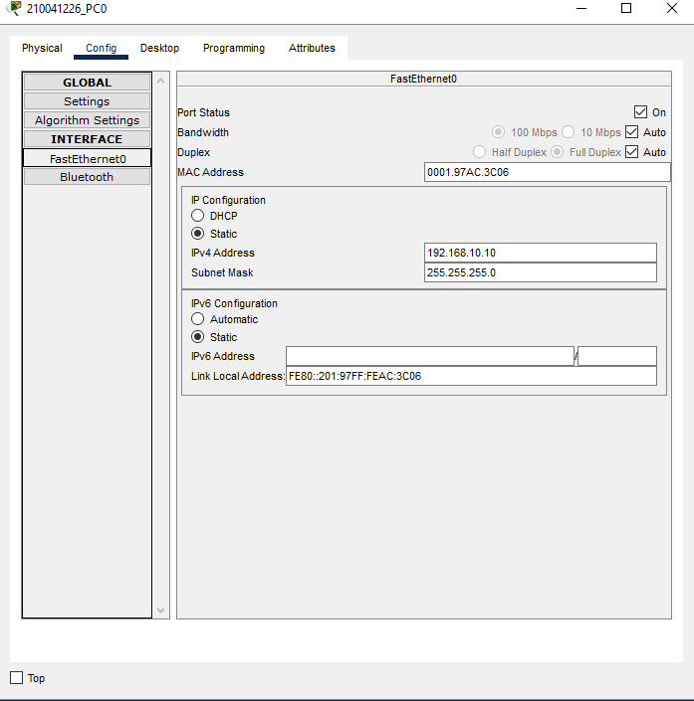

- Now all the interfaces of the Routers were configured in this manner
  - 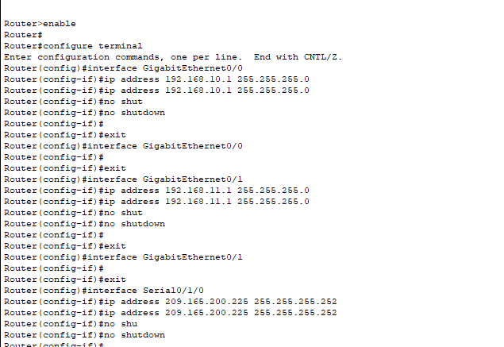

- After that all the connected links with interfaces were changed to up state
  - 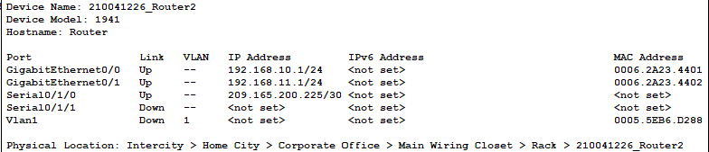

- Then all the connections were tested in this manner adding simple PDU packages from PC to router
  - 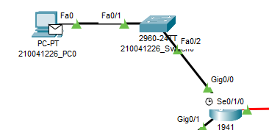
- All the required connections showed this successful messages as the PDU were delivered
  - 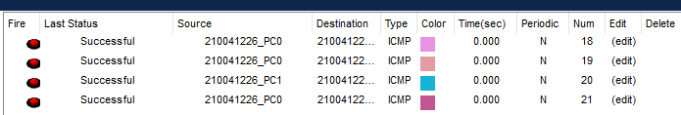

Questions (Answer to the point):
Q1. Write the command for adding a motd banner with the string "Restricted Access. Only for authorized individuals."
Ans: banner motd "Restricted Access. Only for authorized individuals."

Q2. What is the recommended way of enabling password in a cisco device? Why it's better than other methods?
Ans: Using enable secret command. It is better because it encrypts the password using MD5, unlike enable password which stores it in plain text.

Q3. What are the differences between DCE and DTE cables?
Ans:
DCE (Data Communication Equipment): Provides clocking signal, typically used on the provider's side.
DTE (Data Terminal Equipment): Receives clocking, typically used on the customer's side.

Q4. Write the command to check the status of all interfaces in a router.
Ans:show ip interface brief

Q5. How do you make all the configuration changes in a cisco device persistent? What would happen if you don’t do this?
Ans:
Using the command copy running-config startup-config. By doing this the changes made won’t be lost after a power cycle

Challenges (if any):
- Finding out the subnet mask of each Router was a bit difficult
- Configuring the interfaces of each router was troublesome
- For each case testing the PC to router packet and other way around was troublesome. In some cases the packets failed and finding out why was difficult.
- Finding out how the CLI works was troublesome

